LEGACY SYSTEM MAINTAINABILITY

Software Re-engineering
When we need to update the software to keep it to the current market, without impacting its functionality, it is called software re-engineering. It is a thorough process where the design of software is changed and programs are re-written.
Legacy software cannot keep tuning with the latest technology available in the market. As the hardware become obsolete, updating of software becomes a headache. Even if software grows old with time, its functionality does not.
For example, initially Unix was developed in assembly language. When language C came into existence, Unix was re-engineered in C, because working in assembly language was difficult.
Other than this, sometimes programmers notice that few parts of software need more maintenance than others and they also need re-engineering.
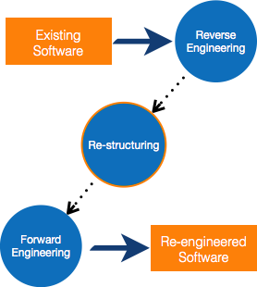

Re-Engineering Process
- Decide what to re-engineer. Is it whole software or a part of it?
- Perform Reverse Engineering, in order to obtain specifications of existing software.
- Restructure Program if required. For example, changing function-oriented programs into object-oriented programs.
- Re-structure data as required.
- Apply Forward engineering concepts in order to get re-engineered software.

Reverse Engineering
It is a process to achieve system specification by thoroughly analyzing, understanding the existing system. This process can be seen as reverse SDLC model, i.e. we try to get higher abstraction level by analyzing lower abstraction levels.
An existing system is previously implemented design, about which we know nothing. Designers then do reverse engineering by looking at the code and try to get the design. With design in hand, they try to conclude the specifications. Thus, going in reverse from code to system specification.
